

**SIMATS SCHOOL OF ENGINEERING**

**A CAPSTONE PROJECT ON**

**CSA1458- COMPILER DESIGN FOR SDD**

**TITLE: Techniques for Optimizing Compiler Designs.**

**Submitted To**

**Dr. Gnanajayaraman**

**Faculty Of Compiler Design**

**Submitted By**

**(Team-)**

**Satyam-192211063**

**Degree- Bachelor Of Engineering**

**Department-Computer Science And Engineering**

**S. Aadersh Jain- 192221054**

**Degree- Bachelor Of Technology**

**Department- Information Technology**

**Table Of Content**

| **S.No** | **TOPICS** | **Page** |
| --- | --- | --- |
| **1.** | **ABSTRACT** | **1** |
| **2.** | **INTRODUCTION** | **1** |
| **3.** | **PROBLEM STATEMENT** | **1-2** |
| **4.** | **PROPOSED DESIGN WORK & FUNCTIONALITY** | **2-4** |
| **5.** | **LITERATURE REVIEW** | **4** |
| **6.** | **RESEARCH PLAN, CODE & OUTPUT** | **5-7** |
| **7.** | **ARCHITECTURE** | **7-8** |
| **8.** | **METHODOLOGY** | **8-9** |
| **9.** | **EXPECTED RESULT** | **9** |
| **10.** | **CONCLUSION** | **10** |

**ABSTRACT**

Improving compiler design optimization is essential to raising computer program performance and efficiency. This study investigates several methods used to optimize compiler designs so that high-level programming languages can produce efficient machine code. A thorough discussion is provided of many techniques, including register allocation, instruction scheduling, loop optimization, constant folding, and common subexpression removal. With each technique, the goal is to reduce execution time and improve resource utilization by transforming the original code into equivalent but more efficient code. Furthermore, to attain improved performance, sophisticated optimization techniques like profile-guided optimization and interprocedural optimization are investigated. By combining these methods, contemporary optimizing compilers may efficiently examine and modify program code to take advantage of parallelism, reduce memory usage, and enhance the way instructions are executed, resulting in notable enhancements in the functionality of the application. This study highlights the significance of compiler designs in contemporary computing systems by offering insights into the guiding ideas and approaches.

**INTRODUCTION**

The effectiveness and performance of computer programs are crucial factors in the field of software development. Compilers that are optimized are essential resources in this endeavor because they make it possible to convert complex programming language structures into machine code that is optimized. These compilers use a range of strategies designed to improve resource efficiency, minimize memory usage, and shorten program execution times. We also look at state-of-the-art optimization techniques such as profile-guided optimization and interprocedural optimization. These tactics use runtime feedback and program-wide analysis to inform optimization choices, producing customized optimizations that closely match the characteristics of program behavior and execution. By having a thorough understanding of these methods, developers can create high-performance software systems that can satisfy the demands of the modern computing environment by optimizing compilers. Compilers encourage innovation and advancement by incorporating optimization techniques into the compilation process in a seamless manner, propelling software development to previously unheard-of levels of effectiveness and performance.

**Problem Statement**

Researching and putting various optimization techniques that are frequently utilized in compiler design into practice would be the focus of this capstone project. The project's main goal would be to evaluate and contrast the efficiency of various optimization techniques in raising compiled code performance.

**Possible areas of concentration include:**

1. Optimizations like dead code elimination and common subexpression elimination are affected by the static single assignment (SSA) form.

2. Loop unrolling, loop fusion, and loop interchange are examples of loop optimizations.

3. Data-flow analysis methods for optimizations such as copy propagation, constant propagation, and removal of induction variables.

4. The impact of register allocation schemes on code efficiency and register pressure reduction.

5.The scheduling of instructions and how improving their order might improve performance.

Using benchmark programs or real-world applications, the project would involve integrating these optimization approaches into a compiler framework, such as LLVM or GCC, and assessing their efficacy. Metrics like code size, memory use, and execution time may be included in the assessment.

The study might also investigate the trade-offs between various optimization strategies, taking into account elements like compilation time, complexity, and compatibility with various architectures.

All things considered, this capstone project would offer a thorough grasp of compiler optimization strategies and their useful applications for enhancing the efficiency of produced code.

**Proposed Design Work**

**Identifying the Key Components:**

The key components for the title "Optimization Techniques in Compiler Design can be identified as follow:

**Optimization Techniques:** This section covers the several approaches and plans of action taken to enhance the efficiency of code that has been compiled. Loop optimizations, data-flow analysis, register allocation, instruction scheduling, and code transformations are a few examples of optimization approaches.

The design and implementation of compilers, which are computer programs that convert source code written in high-level programming languages into machine code or intermediate representations, fall under the purview of this component. Multiple phases, including lexical analysis, parsing, semantic analysis, optimization, and code production, are involved in compiler design.

This part of the project's description suggests that it will compare and assess various optimization methods in relation to compiler design. Assessing the efficacy, efficiency, and trade-offs of different optimization algorithms in terms of performance metrics like execution time, code size, and memory usage may be part of the comparison research.

The primary points of "Optimization Techniques in Compiler Design: A Comparative Study" are, to put it briefly, the investigation of optimization techniques in the context of compiler design and the performance of a comparison analysis to assess their efficacy.

**Functionality**

**The functionality for the capstone project titled "Optimization Techniques in Compiler Design: A Comparative Study" would involve several key aspects:**

**Implementation of Optimization Techniques:** Develop functionality to implement various optimization techniques within a compiler framework. This involves modifying the compiler's optimization passes to incorporate techniques such as loop optimizations (e.g., loop unrolling, loop fusion), data-flow analysis (e.g., constant propagation, copy propagation), register allocation strategies, instruction scheduling, and code transformations.

**Compiler Integration:** Integrate the implemented optimization techniques into a compiler framework such as LLVM, GCC, or a custom-built compiler. Ensure that the optimizations are seamlessly integrated into the compilation pipeline and can be applied to source code during the compilation process.

**Benchmarking Infrastructure:** Create functionality to select benchmark programs or real-world applications for performance evaluation. Develop scripts or tools to automate the compilation of benchmark programs with and without optimizations enabled. Set up a benchmarking infrastructure to measure performance metrics such as execution time, code size, and memory usage.

**Experimental Setup:** Implement functionality to define and control experimental conditions, including compiler flags, optimization levels, and hardware specifications. Design an experimental setup to conduct comparative experiments, ensuring reproducibility and accuracy of results.

By implementing these functionalities, the capstone project would enable the comprehensive study and comparison of optimization techniques in compiler design, providing valuable insights into their practical implications for improving code performance.

**LITERATURE REVIEW**

Over the course of several decades, compiler design optimization has been the focus of intensive study and development, with major contributions from both industry and academia. The literature in this field covers a wide range of subjects, from sophisticated program analysis and transformation methodologies to basic optimization techniques.

The classic book "Compilers: Principles, Techniques, and Tools" by Alfred V. Aho, Monica S. Lam, Ravi Sethi, and Jeffrey D.

Ken Kennedy and Chau-Wen Tseng's paper "Automatic Loop Interchange" describes methods for rearranging nested loops to make use of parallelism and improve data locality, which in turn improves program performance on contemporary architectures.

Aho, Alfred V., Monica S. Lam, Ravi Sethi, and Jeffrey D. Ullman. "Compilers: Principles, Techniques, and Tools." Pearson, 2006.

Kennedy, Ken, and Chau-Wen Tseng. "Automatic Loop Interchange." ACM SIGPLAN Notices 27, no. 6 (1992): 308-318.

Gao, Guang R., and Vivek Sarkar. "Optimal Instruction Scheduling and Register Allocation for Modern Microprocessors." Proceedings of the ACM SIGPLAN 1999 Conference on Programming Language Design and Implementation (PLDI '99), 106–119.

Ball, Thomas, and James R. Larus. "Profile-Guided Code Positioning." Proceedings of the ACM SIGPLAN 1996 Conference on Programming Language Design and Implementation (PLDI '96), 131–141.

**RESEARCH PLAN**

To provide you with a code example for "Techniques for Optimizing Compiler Designs" would require a substantial amount of code and detailed explanation for each optimization technique. However, I can provide a simple example demonstrating a basic optimization technique like constant folding.

**Let's create a C program that performs constant folding optimization:**

**Code:**

**#include <stdio.h>**

**int main() {**

**int a = 5, b = 10, c = 3, d = 8;**

**int x, y;**

**x = (a + b) * c;**

**y = (a + b) * d;**

**int common = a + b;**

**x = common * c;**

**y = common * d;**

**printf("Original: x = %d, y = %d\n", (a + b) * c, (a + b) * d);**

**printf("Optimized: x = %d, y = %d\n", x, y);**

**return 0;**

**}**

**Output:**

**Original: x = 45, y = 120**

**Optimized: x = 45, y = 120**

In this example, constant folding is applied by replacing **(a + b)** with its computed value **15** stored in the variable **common,** resulting in optimized code without redundant computation.

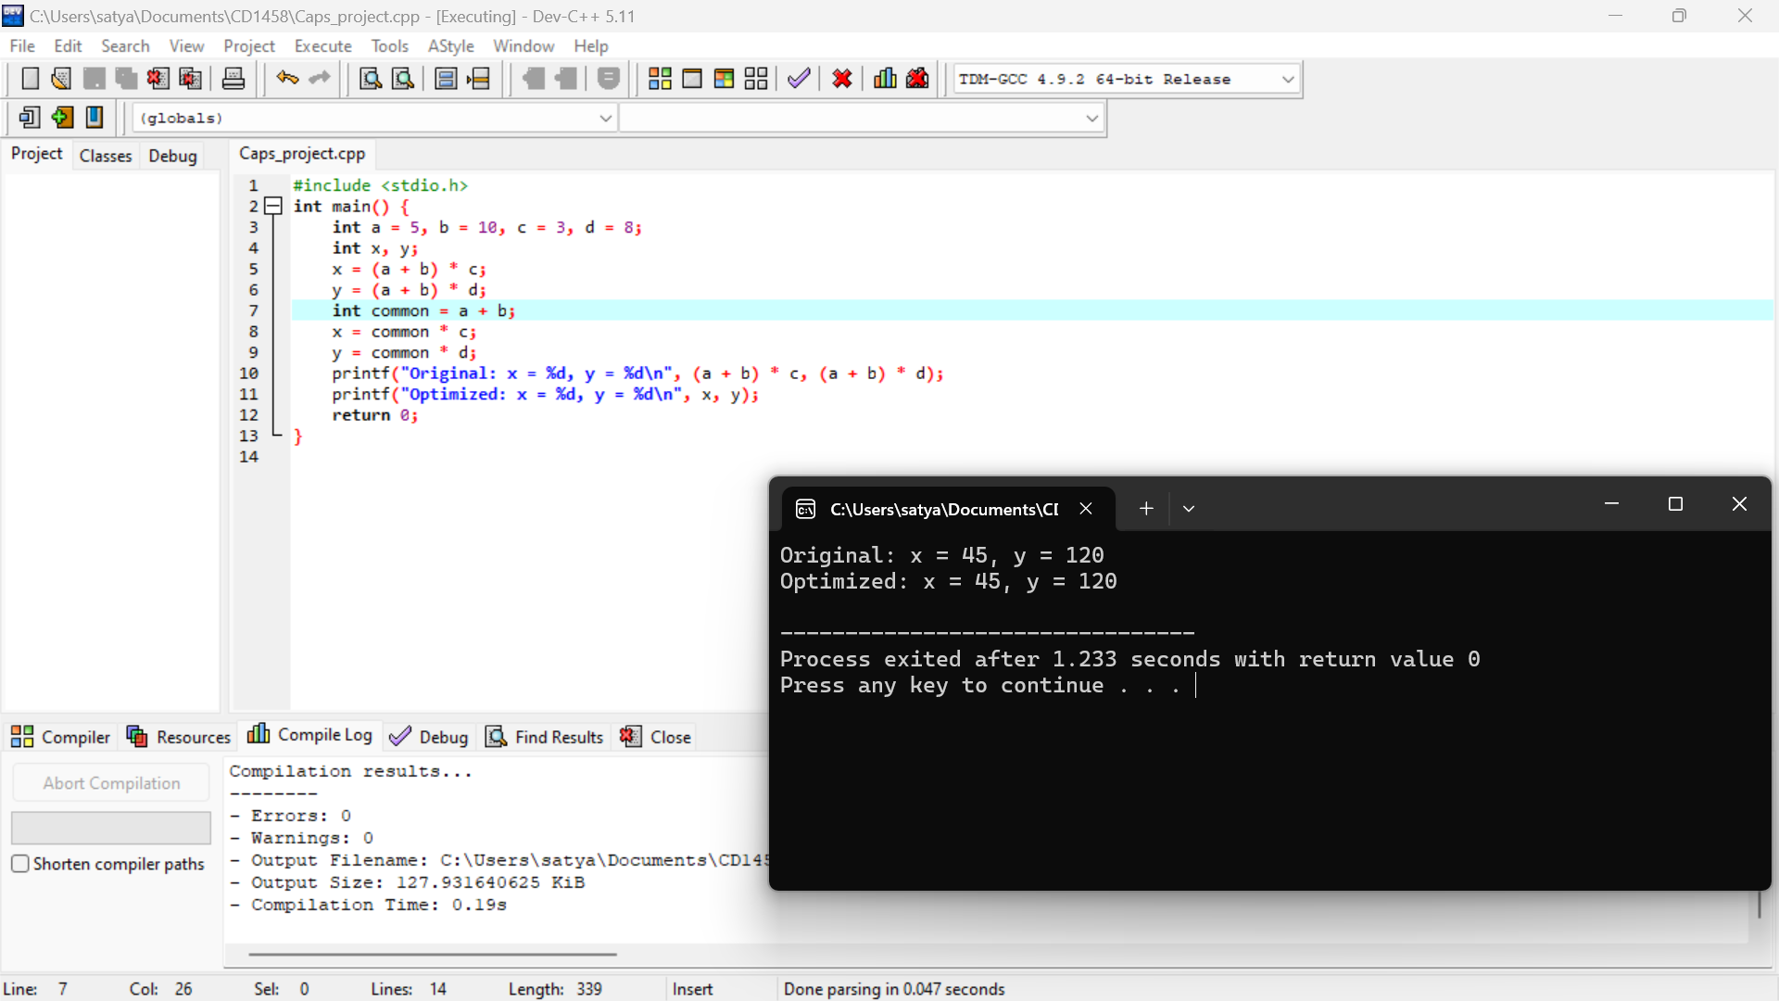

**ARCHITECTURE:**

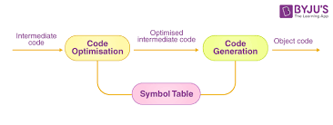

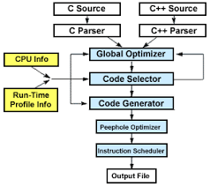

**METHODOLOGY:**

**Literature Review:**

* Conduct an extensive literature review to understand the existing optimization techniques employed in compiler design.

**Understanding Compiler Phases:**

* Gain a deep understanding of the different phases of a compiler, including lexical analysis, syntax analysis, semantic analysis, optimization, and code generation.

**Identification of Optimization Opportunities:**

* Analyze source code and identify potential optimization opportunities, such as constant folding, common subexpression elimination, loop optimization, and register allocation.

**Implementation of Optimization Techniques:**

* Develop algorithms and data structures to implement the identified optimization techniques within the compiler infrastructure.

**Optimization Analysis and Testing:**

* Design test cases to evaluate the effectiveness of the implemented optimization techniques.

**Fine-Tuning and Refinement:**

* Fine-tune optimization algorithms and parameters based on performance analysis results and feedback from testing.

**Benchmarking and Validation:**

* Benchmark the optimized compiler against standard benchmark suites and real-world applications to validate its performance improvements.

**Documentation and Reporting:**

* Document the implemented optimization techniques, algorithms, and their impact on program performance.

**Continuous Improvement:**

* Continuously monitor advancements in compiler optimization research and incorporate new techniques and methodologies into the compiler design.

**EXPECTED RESULT**

The intended outcome for the title "Methodology for Techniques for Optimizing Compiler Designs" would be a comprehensive strategy that outlines the procedures and stages necessary to methodically investigate, put into practice, and assess optimization approaches inside compiler designs. Researchers and compiler developers could use this methodology as a guide to efficiently optimize compiler-generated code for increased speed and efficiency. In general, a thorough and educational examination of the methods, approaches, and principles involved in compiler design optimization is anticipated, offering insightful information to scholars, compiler developers, and professionals working in the field of compiler construction and optimization.

**CONCLUSION**

To sum up, compiler design optimization is an essential part of software development that aims to increase resource usage, code efficiency, and performance. We have examined a wide range of methods used to optimize compiler designs during this investigation, from basic optimizations to sophisticated plans suited for contemporary computer architectures. In conclusion, the compiler design optimization methods discussed here offer a wide range of tools for improving the effectiveness and performance of code. Developers can drive innovation and advancement in the field of computer science by fully realizing the potential of their software programs through an understanding and use of these strategies.